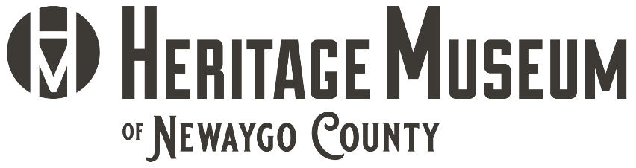
12 Quarterline P.O. Box 361 Newaygo, MI 49337 | (231) 652-5003 | Newaygocounthistory.org

Volunteer Application Form
Name: ____________________________________________________
Address: _______________ City: ____________________ Zip: ________
Phone: __________________________ Phone: ____________________
Email: ____________________________________________________
Emergency Contact: ______________________ Relationship: _ _________
Phone: ______________________Phone: ____________________

Work experience:
__________________________________________________________
__________________________________________________________

Prior Volunteer activities: __________________________________________________________
__________________________________________________________

Please circle months and days available:
January February March April May June July August September
October November December
Monday Tuesday Wednesday Thursday Friday Saturday

Signature _______________________________ Date _____________

Please select and circle the volunteer descriptions on the back of this page to note which activities you may be interested in.

Administration:
- Greeters– Responsible for welcoming visitors and ensuring the visitors have an optimal experience at the Museum.
- Events – Responsible for assisting staff with the planning, setup and takedown of event. In addition, being able to provide support for the event.
Education Department
- Field Trips – The museum host school classes for lessons on many local historical topics. Some of the topics are delivered in small groups and museum volunteers are needed to help.
- Expos/Fairs – The museum participates local events by generally providing a booth with information and an activity for the children. The booth is occupied by museum volunteers.
- Archaeology – Each summer the museum provides a Kids Week Archaeology Camp. Students get “real life” archaeology experience. Many museum volunteers are needed for this program (must be willing to get dirty and work closely with 10- to 14-year-olds).
- Tour Guides – The museum occasionally schedules private tours of the museum and volunteers are required to be knowledgeable about the museum and local history (training available).
Gift Gallery
- Gift Gallery Assistants – Responsible for assisting visitors regarding gift shop item questions and the purchase of items.
- Inventory & Stocking – Responsible for counting physical inventory & restocking items as needed.
Artifact Collections Department
- Data Entry Assistants – Responsible for entering artifact information into the Past Perfect Museum Software system.
- Exhibit Display – Responsible for processing and handling of artifacts & other materials used to create displays.
- Exhibit Research – Responsible for researching information to be used for the gallery exhibits.
Building & Maintenance
- Construct & maintain Exhibits – Work with wood and paint to build cubes & display cases and forms for the effective display of artifacts.
- Enhance storage & work areas – Build and organize shelving and storage areas of the museum.
- Maintain Facilities – Help keep the museum in tip top shape. May include painting, cleaning, shoveling, and other basic maintenance.

